**1.INTRODUCTION**

* 1. **PROJECT SCOPE**

This study aims defining and experimenting new techniques able to automatically recognize human activities exploiting signals recorded by wearable and/or environmental devices. HAR is the problem of classifying day-to-day human activity using data collected from smartphone sensors. Data are continuously generated from the accelerometer and gyroscope, and these data are instrumental in predicting our activities such as walking or standing.

* 1. **PROJECT PURPOSE**

Human beings can realize others’ psychological state and personality by observing their daily activities. Following this pattern, the researchers want to predict human behavior using machines, and Human Behavior Recognition (HAR) comes as an active research topic. The project focuses on these objectives, which are:

* To suggest ways to detect various day-to-day human activities.
* In the majority of cases, environmental devices require an installation in the home environment and devices such as cameras are perceived as intrusive devices.
* Techniques based on signals from sensors of wearable devices have been proposed for several application domains: sport tracking uses signals such as GPS and accelerometer
  1. **PROJECT FEATURES**

The main features of this project are that this model classifies the It addresses the problem of learning hierarchical representations with a single algorithm or a few algorithms. There are different deep learning approaches like Convolutional Neural Network (CNN). We have experimented several personalization methods on three public datasets in order to make the results reproducible and thus allowing future research on this topic. The personalization methods experimented are based on the concept of similarities between users.

**2. LITERATURE SURVEY**

* + - This paper surveys the recent advance of deep learning-based sensor-based activity recognition. We summarize existing literature from three aspects: sensor modality, deep model, and application. It also presents detailed insights on existing work and propose grand challenges for future research. Comparative Study of Machine Learning and Deep Learning Architecture for Human Activity Recognition Using Accelerometer Data
    - It investigates the HAR based on the data collected through the accelerometer sensor of mobile devices. It employs different machine learning (ML) classifiers, algorithms, and deep learning (DL) models across different benchmark datasets. The experimental results from this study provide a comparative performance analysis based on accuracy, performance, and the costs of different ML algorithms and DL algorithms, based on recurrent neural network (RNN) and convolutional neural network (CNN) models for activity recognition.
    - This system is able to recognize the activities such as Laying, Sitting, Standing, Walking, Walking downstairs and Walking upstairs. Benchmark dataset has been used to evaluate all the classifiers implemented. Have investigated all these classifiers to identify a best suitable classifier for this dataset.

**3.SYSTEM ANALYSIS**

System Analysis is the important phase in the system development process. The System is studied to the minute details and analyzed. The system analyst plays an important role of an interrogator and dwells deep into the working of the present system. In analysis, a detailed study of these operations performed by the system and their relationships within and outside the system is done. A key question considered here is, “what must be done to solve the problem?” The system is viewed as a whole and the inputs to the system are identified. Once analysis is completed the analyst has a firm understanding of what is to be done.

* 1. **PROBLEM DEFINITION**

The goal of the project is Human activity recognition (HAR). It is a field of research that aims at defining and experimenting new techniques able to automatically recognize human activities exploiting signals recorded by wearable and/or environmental devices. Recently, a significant amount of literature concerning machine learning techniques has focused on automatic recognition of activities performed by people.

* 1. **EXISTING SYSTEM**

Several factors may affect the accuracy of activity recognition methods: i) position of the device (e.g., pocket, hand, or bag); ii) differences between different brands of sensors, in terms of sensitivity range and sampling frequency; iii) human characteristics, such as age, gender, weight, height, lifestyle, and physical abilities. While factors related to the position and the characteristics of the devices have been largely investigated, few works have explored the effects of human characteristics on recognition accuracy.

**3.2.1 DISADVANTAGES OF EXISTING SYSTEM**

The existing system uses motion detection sensors and other devices which cause distortions and cannot predict the difference between humans and other objects.

* 1. **PROPOSED SYSTEM**

We focus on the recognition of human activities using signals acquired by the accelerometer embedded in a smartphone. The contributions of this research are mainly three. A first contribution is the definition of a clear validation model that takes into account the problem of personalization and which thus makes it possible to objectively evaluate the performances of machine learning algorithms. A second contribution is the evaluation, on three different public datasets, of a personalization model which considers two aspects: the similarity between people related to physical aspects (age, weight, and height) and similarity related to intrinsic characteristics of the signals produced by these people when performing activities. A third and last contribution is the development of a personalization model that considers both the physical and signal similarities. The experiments show that the employment of personalization models improves, on average, the accuracy, thus confirming the soundness of the approach and paving the way for future investigations on this topic.

Human beings can realize others’ psychological state and personality by observing their daily activities. Following this pattern, the researchers want to predict human behaviour using machines, and Human Behaviour Recognition (HAR) comes as an active research topic. This has become one of the important research topics in machine learning and computer vision. Though motion data collection was hard in previous days, current technological developments help researchers capture the data as they can now use portable devices, including smartphones, music players, smartwatches, or smart home sensors. Especially, motion sensor embedded smartphones, like accelerometers, gyroscope, etc. bring a new era for activity recognition. Researchers use various machine learning and deep learning techniques including

Naive Bayes (NB), Decision Tree, Support Vector Machine (SVM), Nearest Neighbour (NN), Hidden Markov Model (HMM), Convolutional Neural Network (CNN) etc. to analyse the sensor data and recognize human activity.

HAR is the problem of classifying day-to-day human activity using data collected from smartphone sensors. Data are continuously generated from the accelerometer and gyroscope, and these data are instrumental in predicting our activities such as walking or standing. There are lots of datasets and ongoing research on this topic. In, the authors discuss wearable sensor data and related works of predictions with machine learning techniques. Wearable devices can predict an extensive range of activities using data from various sensors. Deep Learning models are also being used to predict various human activities. Nowadays, people use smartphones almost all the time and use many wearable devices. Through these devices, physical and mental health can be monitored by predicting human activity without specialized and costly medical equipment, and nowadays, it is an efficient, cheap, and safe way to do this as the COVID-19 (Coronavirus disease 2019) pandemic is ongoing.

Human activity recognition (HAR) is a field of research that aims at defining and experimenting new techniques able to automatically recognize human activities exploiting signals recorded by wearable and/or environmental devices. In the majority of cases, environmental devices require an installation in the home environment and devices such as cameras are perceived as intrusive devices, especially by elderly people. For these reasons, in recent years the focus has shifted to the use of wearable devices. Among them, special attention is currently being paid to smartphones, smartwatches, and fitness devices. This is mainly due to their wide diffusion among the population and to the presence of various types of sensors integrated in the devices (e.g., accelerometer, gyroscope, orientation, and GPS). HAR techniques based on signals from sensors of wearable devices have been proposed for several application domains: sport tracking uses signals such as GPS and accelerometer for evaluating the activity of the user, detection of falls exploits wearable devices preventing mortality of elder people,

5

behaviour analysis, based on physical measurements, prevents dementia diseases, and many others. Most of these HAR techniques rely on accelerometers because they have low power consumption and permit continuous sensing over a complete day.

In this paper we have experimented several personalization methods on three public datasets in order to make the results reproducible and thus allowing future research on this topic. The personalization methods experimented are based on the concept of similarity between users. This means that users may have similar physical characteristics or have similar accelerometer signals and that, such a similarity can be employed to weight training data in a way that data belonging to more similar subjects to the subject under test count more than data of less similar subjects.

6

**3.3.1ADVANTAGES OF THE PROPOSED SYSTEM**

* The detected abnormal behavior is corrected through alarms in real time.
* Component establishes interface with other drivers very easily.
* Life of driver can be saved by alerting him using the alarm system.
  1. **FEASIBILITY STUDY**

The feasibility of the project is analysed in this phase and a business proposal is put forth with a very general plan for the project and some cost estimates. During system analysis the feasibility study of the proposed system is to be carried out. This is to ensure that the proposed system is not a burden to the company. Three key considerations involved in the feasibility analysis:

* Economic Feasibility
* Technical Feasibility
* Social Feasibility

7

* + 1. **ECONOMIC FEASIBILITY**

The developing system must be justified by cost and benefit. Criteria to ensure that effort is concentrated on a project, which will give best, return at the earliest. One of the factors, which affect the development of a new system, is the cost it would require. The following are some of the important financial questions asked during preliminary investigation:

* The costs conduct a full system investigation.
* The cost of the hardware and software.
* The benefits in the form of reduced costs or fewer costly errors.

Since the system is developed as part of project work, there is no manual cost to spend for the proposed system. Also, all the resources are already available, it give an indication that the system is economically possible for development.

* + 1. **TECHNICAL FEASIBILITY**

This study is carried out to check the technical feasibility, that is, the technical requirements of the system. Any system developed must not have a high demand on the available technical resources. The developed system must have a modest requirement, as only minimal or null changes are required for implementing this system.

* + 1. **BEHAVIORAL FEASIBILITY**

This includes the following questions:

* Is there sufficient support for the users?
* Will the proposed system cause harm?

The project would be beneficial because it satisfies the objectives when developed and installed. All behavioral aspects are considered carefully and conclude that the project is behaviorally feasible

8

* 1. **HARDWARE & SOFTWARE REQUIREMENTS**
     1. **HARDWARE REQUIREMENTS:**

Hardware interfaces specify the logical characteristics of each interface between the software product and the hardware components of the system. The following are some hardware requirements.

* Processor: Intel Dual Core I5 and above
* Hard disk: 8GB and above
* RAM: 8GB and above
* Input devices: Keyboard, mouse.
  + 1. **SOFTWARE REQUIREMENTS:**

Software Requirements specifies the logical characteristics of each interface and software components of the system. The following are some software requirements

* Operating system: Windows 8 and above
* Languages: Python.
* Tools: Python IDEL3.7, Jupiter Notebook, Visual studio code.

9

# 4. ARCHITECTURE

Project architecture shows the procedure followed for classification, starting from input to final prediction.

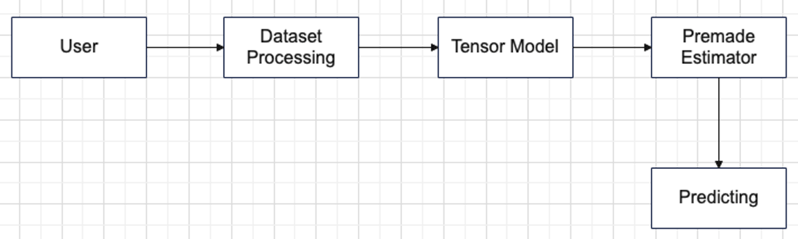

**Figure 4.1: Project Architecture of Human Activity Recognition**

* 1. **Description**

First, we will collect values from accelerometer and gyroscope then we perform data analysis followed by data preprocessing of the datasets. After preprocessing data goes through Tensor Model we get estimated values, using those estimated values we predict and classify the human activity.

10

**4.2 USE CASE DIAGRAM**

In the use case diagram, we have basically one actor who is the user in the trained model. A use case diagram is a graphical depiction of a user's possible interactions with a system. A use case diagram shows various use cases and different types of users the system has. The use cases are represented by either circles or ellipses. The actors are often shown as stick figures.

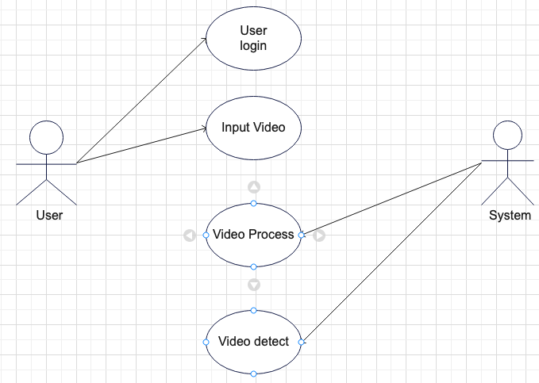

**Figure 4.2 Use Case Diagram for Human Activity Recognition**

11

**4.3 CLASS DIAGRAM**

Class diagram is a type of static structure diagram that describes the structure of a system by showing the system’s classes, their attributes, operations (or methods), and the relationships among objects.

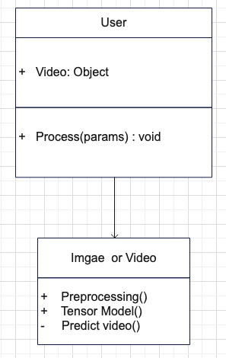

**Figure 4.3: Class Diagram for Human Activity Recognition**

12

* 1. **SEQUENCE DIAGRAM**

A sequence diagram shows object interactions arranged in time sequence. It depicts the objects involved in the scenario and the sequence of messages exchanged between the objects needed to carry out the functionality of the scenario. Sequence diagrams are typically associated with use case realizations in the logical view of the system under development.

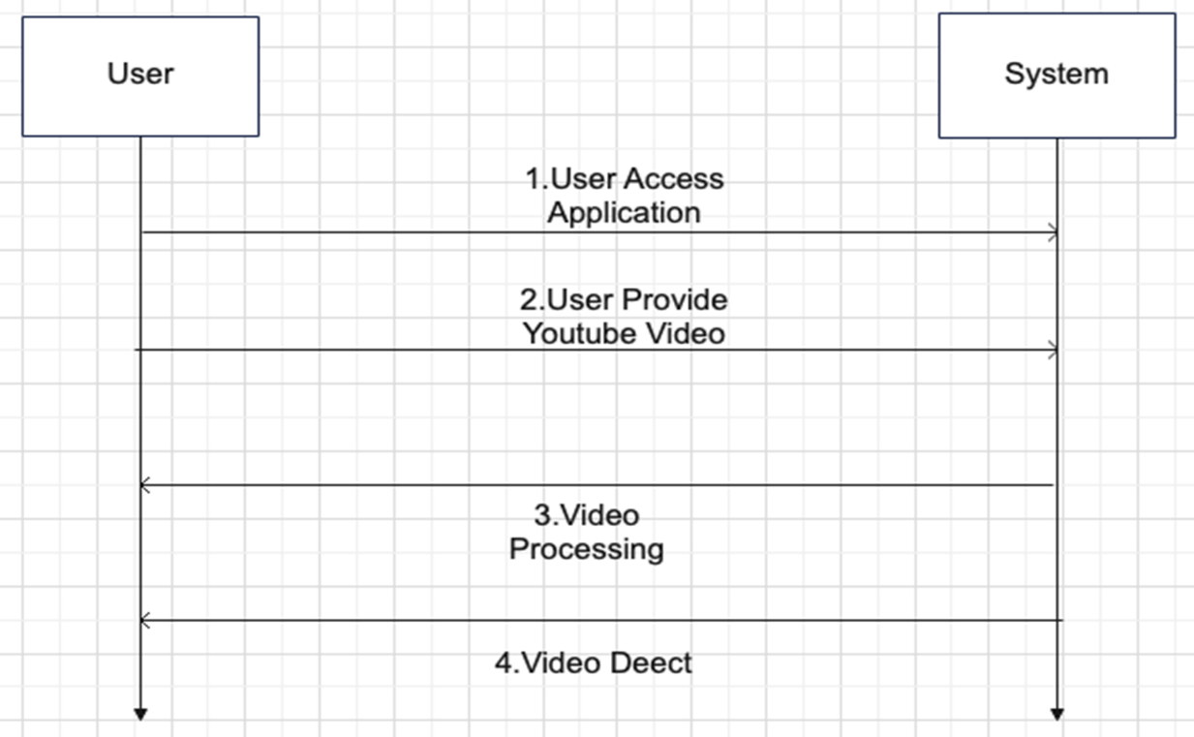

Figure 4.4: Sequence Diagram for Human Activity Recognition

13

* 1. **ACTIVITY DIAGRAM**

Activity diagrams are graphical representations of workflows of stepwise activities and actions with support for choice, iteration and concurrency. They can also include elements showing the flow of data between activities through one or more data stores.

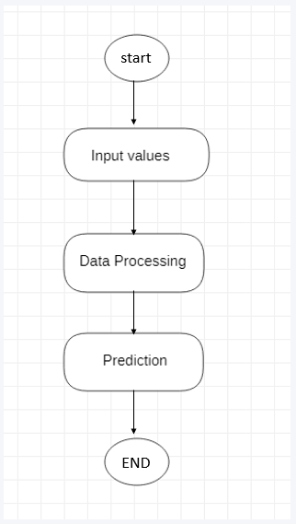

Figure 4.5: Activity Diagram for Human activity recognition

14

## 5.IMPLEMENTATION

### SAMPLE CODE

# Importing all necessary libraries

import cv2

import os

from keras.models import load_model

from keras. preprocessing. image import load_img, img_to_array

from keras. preprocessing import image

import numpy as np

import shutil

import glob

from flask import Flask, redirect, url_for, request, render_template, Markup

from tensorflow. keras. models import load_model

import random

import pandas as pd

import requests

import config

import sklearn

from PIL import Image

import pickle

import tensorflow as tf

import sqlite3

app = Flask(_name_)

@ app.route('/')

def form (): title = 'Human Activity Recognition return render_template ('form.html',

15

title=title)

# render crop recommendation form page

@ app.route('/predict1', methods=['POST'])

def predict1():

ACTIVITIES = {0: 'WALKING',1: 'WALKING_UPSTAIRS',2: 'WALKING_DOWNSTAIRS',3: 'SITTING',4: 'STANDING',5: 'LAYING'}

body_acc_x = float(request.form['1'])

body_acc_y = float(request.form['2'])

body_acc_z = float(request.form['3'])

body_gyro_x=float(request.form['4'])

body_gyro_y=float(request.form['5'])

body_gyro_z=float(request.form['6'])

total_acc_x=float(request.form['7'])

total_acc_y=float(request.form['8'])

total_acc_z=float(request.form['9'])

input_array=[body_acc_x,body_acc_y,body_acc_z,body_gyro_x,body_gyro_y, body_gyro_z,total_acc_x,total_acc_y,total_acc_z]

lst=[]

for i in range(128):

lst.extend(input_array)

inp=np.array(lst)

l=inp.reshape(1,128,9)

json_file = open('model.json', 'r')

loaded_model_json = json_file.read()

16

json_file.close()

loaded_model tf.keras.models.model_from_json(loaded_model_json)

# load weights into new model

loaded_model.load_weights("model.h5")

result=loaded_model.predict(l)

prediction = (np.argmax(result[0], axis=0))

return render_template('result.html',predictionACTIVITIES[prediction])

if _name_ == '_main_':

app.run(debug=True)

<html lang="en">

<head>

<meta charset="UTF-8">

<meta name="viewport" content="width=device-width, initial-scale=1.0">

<meta http-equiv="X-UA-Compatible" content="ie=edge">

<title>HAR</title>

<link href="https://cdn.bootcss.com/bootstrap/4.0.0/css/bootstrap.min.css" rel="stylesheet">

<script src="https://cdn.bootcss.com/popper.js/1.12.9/umd/popper.min.js"></script>

<script src="https://cdn.bootcss.com/jquery/3.3.1/jquery.min.js"></script>

<script src="https://cdn.bootcss.com/bootstrap/4.0.0/js/bootstrap.min.js"></script>

<link href="{{ url_for('static', filename='css/main.css') }}" rel="stylesheet">

<style>.heading{color: gray;

font-family: algerian;

background-color: black;

font-style: italic;

animation-name: sample;

animation-duration: 2s;

17

animation-direction: alternate;

animation-iteration-count: infinite;

animation-timing-function: linear;

}

@keyframes spin {

0% { transform: rotate(0deg); }

100% { transform: rotate(360deg); }

}

body{

background-color: gray;

}

</style>

</head>

<body>

<div class='heading'>

<marquee behavior="alternate" direction="left" scrollamount="15">

<h1 >Human Activity Recognition</h1>

</marquee>

</div>

<nav class="navbar navbar-expand-lg navbar-dark bg-dark">

<h3 class="navbar-brand"> Human Activity Recognition </h3>

<button class="navbar-toggler" type="button" data-toggle="collapse" data-target="#navbarNav" aria-controls="navbarNav" aria-expanded="false" aria-label="Toggle

navigation">

<span class="navbar-toggler-icon"></span>

</button>

</nav>

<div id="carouselExampleCaptions" class="carousel slide" data-ride="carousel">

18

<ol class="carousel-indicators">

<li data-target="#carouselExampleCaptions" data-slide-to="0" class="active"></li>

<li data-target="#carouselExampleCaptions" data-slide-to="1"></li>

<li data-target="#carouselExampleCaptions" data-slide-to="2"></li>

</ol>

<div class="carousel-inner">

<div class="carousel-item active">

<img src="{{url_for('static', filename='shutterstock_1384554629-898x505.jpg')}}" class="d-block w-100" alt="AI Image" height="450" >

<div class="carousel-caption d-none d-md-block">

</div>

</div>

<div class="carousel-item">

<img src="{{url_for('static', filename='maxresdefault.jpg')}}" class="d-block w-100" alt="AI Image" height="450">

<div class="carousel-caption d-none d-md-block">

</div>

</div>

<div class="carousel-item">

<img src="{{url_for('static', filename='normal_Human_activity_recognition.jpg')}}" class="d-block w-100" alt="AI Image" height="450" >

<div class="carousel-caption d-none dmd-block">

19

</div>

</div>

</div>

<a class="carousel-control-prev" href="#carouselExampleCaptions" role="button" data-slide="prev">

<span class="carousel-control-prev-icon" aria-hidden="true"></span>

<span class="sr-only">Previous</span>

</a>

<a class="carousel-control-next" href="#carouselExampleCaptions" role="button" data-slide="next">

<span class="carousel-control-next-icon" aria-hidden="true"></span>

<span class="sr-only">Next</span>

</a>

</div>

<br>

<div class="container">

<div id="content" style="margin-top:2em">{% block content %}{% endblock %}</div> </div>

<br><br><br>

<div class="card-deck">

<div class="card text-white bg-secondary mb-3" style="margin-left: 25px; margin-right: 25px;">

<img src="{{url_for('static', filename='hlogo1.jpg')}}" class="card-img-top" alt="..." height="250px" width="130px">

<div class="card-body">

<p class="card-text"> <h3 style="text-align: center;">Human Activity Recognition</h3 <p style="text-align: center;">Human activity recognition plays<br>

20

a significant role in human-to-human<br>

interaction and interpersonal relations.<br>

Because it provides information about the <br>

identity of a person, their personality,<br>

and psychological state, it is difficult<br>

to extract.</p>

</div>

</div>

<div class="card text-white bg-dark mb-3" style="margin-left: 25px; margin-right: 25px;">

<img src="{{url_for('static', filename='hlogo2.jpg')}}" class="card-img-top" alt="..." height="250px" width="130px" >

<div class="card-body">

<p class="card-text">

<h3 style="text-align: center;">Human Activity Recognition</h3>

<p style="text-align: center;">Human activity recognition, or HAR, is a challenging<br>

time series classification task.

It involves predicting the movement<br>

of a person based on sensor data and<br>

traditionally involves deep domain expertise<br>

and methods from signal processing to <br>

correctly engineer features from the raw<br>

data in order to fit a machine learning model.</p></div></div>

<div class="card text-white bg-secondary mb-3" style="margin-left: 25px; margin-right: 25px;">

<img src="{{url_for('static', filename='hlogo3.jpg')}}" class="card-img-top" alt="..." height="250px" width="130px">

<div class="card-body">

21

<p class="card-text">

<h3 style="text-align: center;">Human Activity Recognition !!!</h3>

<p style="text-align: center;">

Recently, deep learning methods such<br>

as convolutional neural networks and <br>

recurrent neural networks have shown <br>

capable and even achieve state-of-the-art<br>

results by automatically learning features<br>

from the raw sensor data.</p></p>

</div>

</div>

</div>

<br>

<hr>

<div style="text-align: center;">

<p>&#169; <small>Copyrights 2022</small> All rights reserved</p>

<br><br></div>

</body>

<footer>

<script src="{{ url_for('static', filename='js/main.js') }}" type="text/javascript"></script>

</footer>

</html>

{% extends "base.html" %} {% block content %}

<center style="margin-top: 5%;">

<h2>Human Activity Classification</h2>

<div>

<h2><center>ACTIVITY: {{prediction}}</center></h2>

</div> </center>{% endblock %}

22

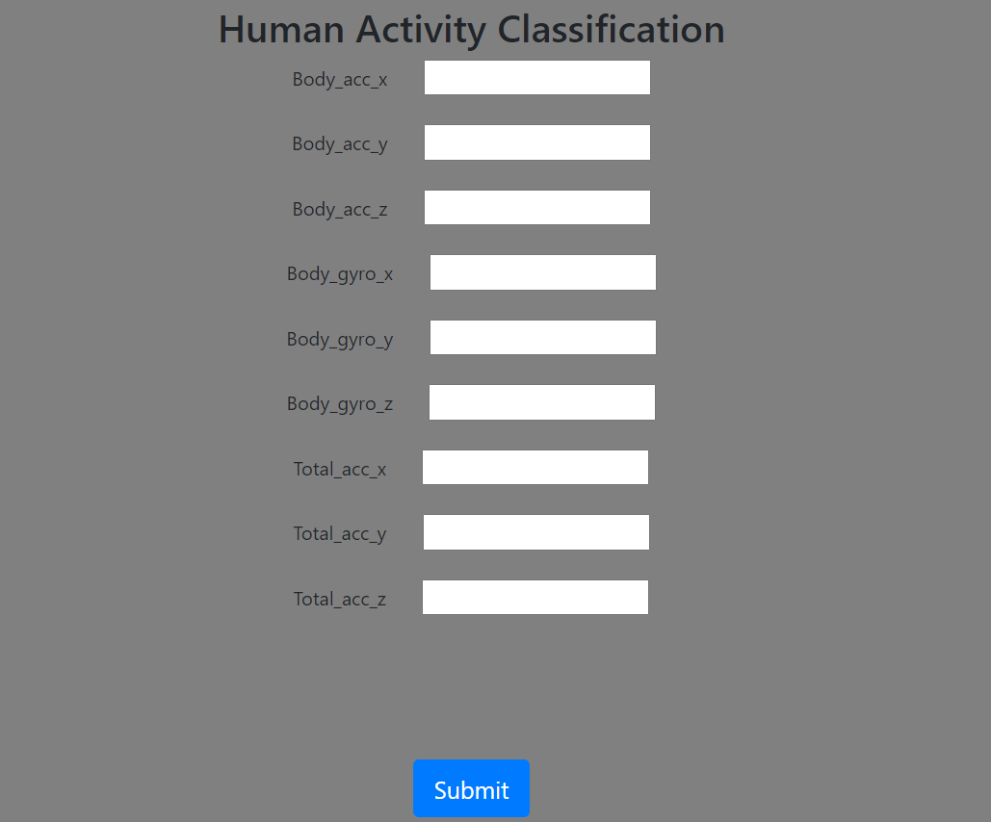

Screenshot 6.1: Launching the site

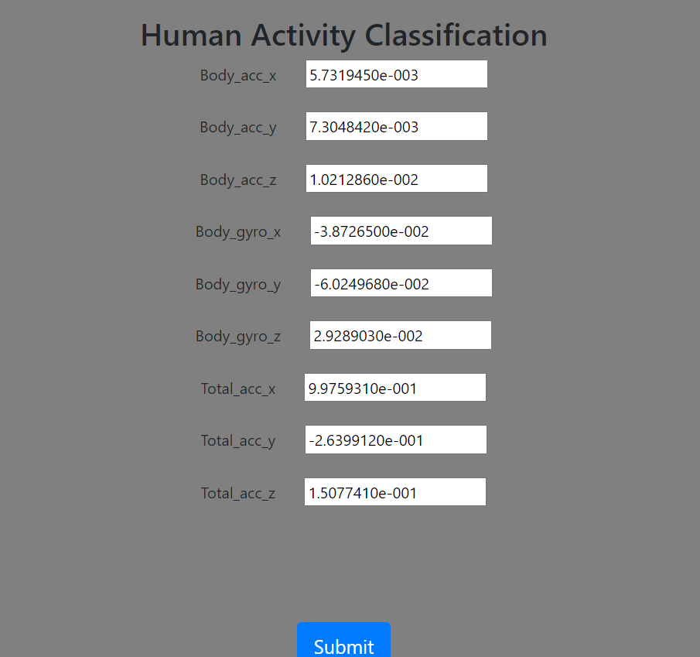

Screenshot 6.2: Providing Input values

23



Screenshot 6.3: Activity detection

24

**7.TESTING**

* 1. **INTRODUCTION TO TESTING**

The purpose of testing is to discover errors. Testing is the process of trying to discover every conceivable fault or weakness in a work product. It provides a way to check the functionality of components, subassemblies, assemblies and/or a finished product. It is the process of exercising software with the intent of ensuring that the Software system meets its requirements and user expectations and does not fail in an unacceptable manner. There are various types of tests. Each test type addresses a specific testing requirement.

* 1. **TYPES OF TESTING**

**7.2.1 UNIT TESTING**

Unit testing involves the design of test cases that validate that the internal program logic is functioning properly, and that program inputs produce valid outputs. All decision branches and internal code flow should be validated. It is the testing of individual software units of the application .It is done after the completion of an individual unit before integration. This is a structural testing that relies on knowledge of its construction and is invasive. Unit tests perform basic tests at component level and test a specific business process, application and/or system configuration. Unit tests ensure that each unique path of a business process performs accurately to the documented specifications and contains clearly defined inputs and expected results

25

**7.2.2 INTEGRATION TESTING**

Integration tests are designed to test integrated software components to determine if they actually run as one program. Integration tests demonstrate that although the components were individually satisfactory, as shown by successfully unit testing, the combination of components is correct and consistent. Integration testing is specifically aimed at exposing the problems that arise from the combination of components.

**7.2.3 FUNCTIONAL TESTING**

Functional tests provide systematic demonstrations that functions tested are available as specified by the business and technical requirements, system documentation, and user manuals.

Functional testing is centered on the following items:

Valid Input: identified classes of valid input must be accepted.

Invalid: identified classes of invalid input must Input be rejected.

Functions: identified functions must be exercised.

Output: identified classes of application outputs must be exercised.

Systems/Procedures : interfacing systems or procedures must be invoked.

Organization and preparation of functional tests is focused on requirements, key functions, or special test cases.

**7.3 TEST RESULT**

|  |  |  |  |
| --- | --- | --- | --- |
| **Test case** | **Expected Result** | **Result** | **Remarks (If fails)** |
| Provide input data. | Predict the output using the values provided | Displays the activity | It shows error if the given input is not valid |

Table 7.1: Test Cases of Human activity recognition

26

**8. CONCLUSION & FUTURE SCOPE**

**8.1 PROJECT CONCLUSION**

We have combined personalization methods with suitable splits of the data: subject-independent and hybrid. The first split considers training set made of data from all the subjects but the subject under test, while the second split considers a training set made of data from all the subjects but the user under test and a small amount of data of the user under test Experiments, on average, prove that personalization methods improve accuracy of the classifier only if combined with a hybrid split. In this case the increment of accuracy, on average, is of about 11%.

27

**9. BIBLIOGRAPHY**

**9.1 REFERENCES**

1. Kensho Hara, Hirokatsu Kataoka, Yutaka Satoh, (2018 April). Can Spatiotemporal 3D CNNs Retrace the History of 2D CNNs and ImageNet?
2. Moez Baccouche, Franck Mamalet, Christian Wolf, Christophe Garcia, and Atilla Baskurt Asa, (2011). Sequential Deep Learning for Human Action Recognition
3. Shikhar Sharma, Ryan Kiros & Ruslan Salakhutdinov, (2016 February). Action Recognition using Visual Attention.
4. Ishan Agarwal, Alok Kumar Singh Kushwaha, Rajeev Srivastava, (2015). Weighted Fast Dynamic Time Warping Based Multiview Human Activity Recognition Using a RGB-D Sensor
5. Hui Huang, Xian Li, Ye Sun, (2016 August). A triboelectric motion sensor in wearable body sensor network for human activity recognition

**10. GITHUB LINK**

28